CSA0501-DATABASE MANAGEMENT SYSTEMS
LAB EXPERIMENTS DATE: 26/08/2026
Exp. No. 20
MYSQL STRING FUNCTIONS – REPLACE, REPEAT, REVERSE, RIGHT, LEFT, RPAD, LPAD
AIM:
To implement Replace, Repeat, Reverse, Right, Left, Rpad and Lpad String Functions using MySQL.
REPLACE()
MySQL REPLACE() replaces all the occurrences of a substring within a string.
Syntax : REPLACE(str,from_str,to_str)
REPEAT()
MySQL REPEAT() repeats a string for a specified number of times. The function returns NULL if any of the arguments are NULL.
Syntax : REPEAT(str,count)
REVERSE()
Returns a given string with the order of the characters reversed.
Syntax : REVERSE(str)
RIGHT()
MySQL RIGHT() extracts a specified number of characters from the right side of a given string.
Syntax : RIGHT(str,len)
LEFT()
MySQL LEFT() returns a specified number of characters from the left side of a given string.
Syntax : LEFT(str,len)
RPAD()
MySQL RPAD() function pads strings from right. The actual string, length of the returned string and padding string are supplied as parameters.
Syntax : RPAD(str,len,padstr)
LPAD()
MySQL LPAD() left pads a string with another string. The actual string, length and padding string are passed as arguments.
Syntax : LPAD(str,len,padstr)
ASCII()
This function returns the numeric value of the leftmost character of the string str. Returns 0 if str is the empty string and NULL if str is NULL.
Syntax : ASCII(str)
BIN()
Returns a string representation of the binary value of N, where N is a longlong (BIGINT) number. Returns NULL if N is NULL.
Syntax : BIN(N)
OCT()
Returns a string representation of the octal value of N, where N is a longlong (BIGINT) number. Returns NULL if N is NULL.
Syntax : OCT(N)
PROGRAM:
Implement the above MySQL string functions using the Passenger table of the Flight Reservation System.
USE Flight_Reservation;
SELECT
Passenger_Name,
REPLACE(Passenger_Name, 'a', '@') AS Replace_Name,
REPEAT(Passenger_Name, 2) AS Repeat_Name,
REVERSE(Passenger_Name) AS Reverse_Name,
RIGHT(Passenger_Name, 3) AS Right_3,
LEFT(Passenger_Name, 3) AS Left_3,
RPAD(Passenger_Name, 15, '*') AS RPad_Name,
LPAD(Passenger_Name, 15, '*') AS LPad_Name,
ASCII(LEFT(Passenger_Name, 1)) AS ASCII_Value
FROM Passenger;
SELECT
BIN(Passenger_ID) AS Binary_ID,
OCT(Passenger_ID) AS Octal_ID
FROM Passenger;
OUTPUT:
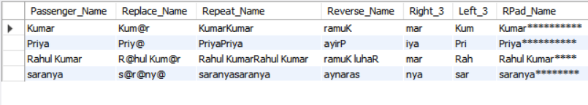

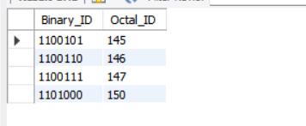

RESULT:
Thus the String Functions such as Replace, Repeat, Reverse, Right, Left, Rpad and Lpad are executed successfully.

